**Kelso Choice Boards Promote Student-Led Problem Solving at Recess**

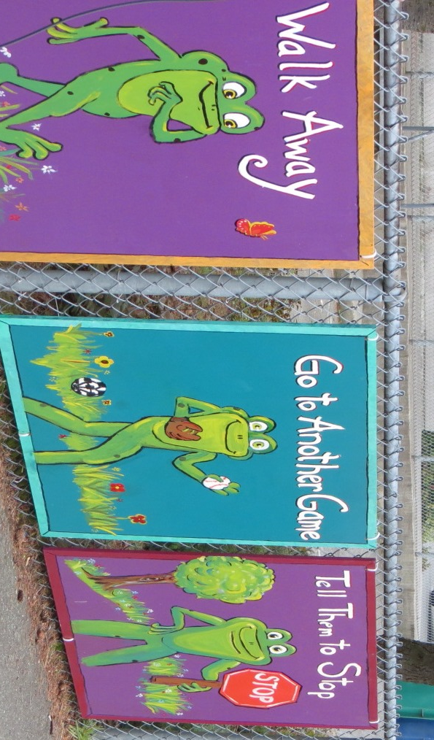

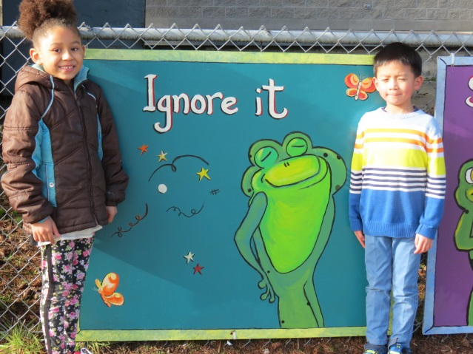

Wait and cool off Walk away

Go to another game Tell them to stop

Talk it out Apologize

Share and take turns Make a deal

Ignore it

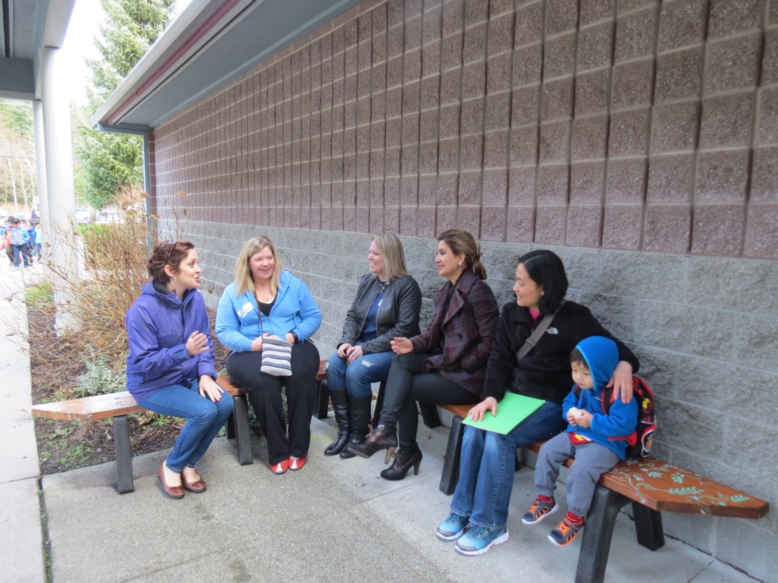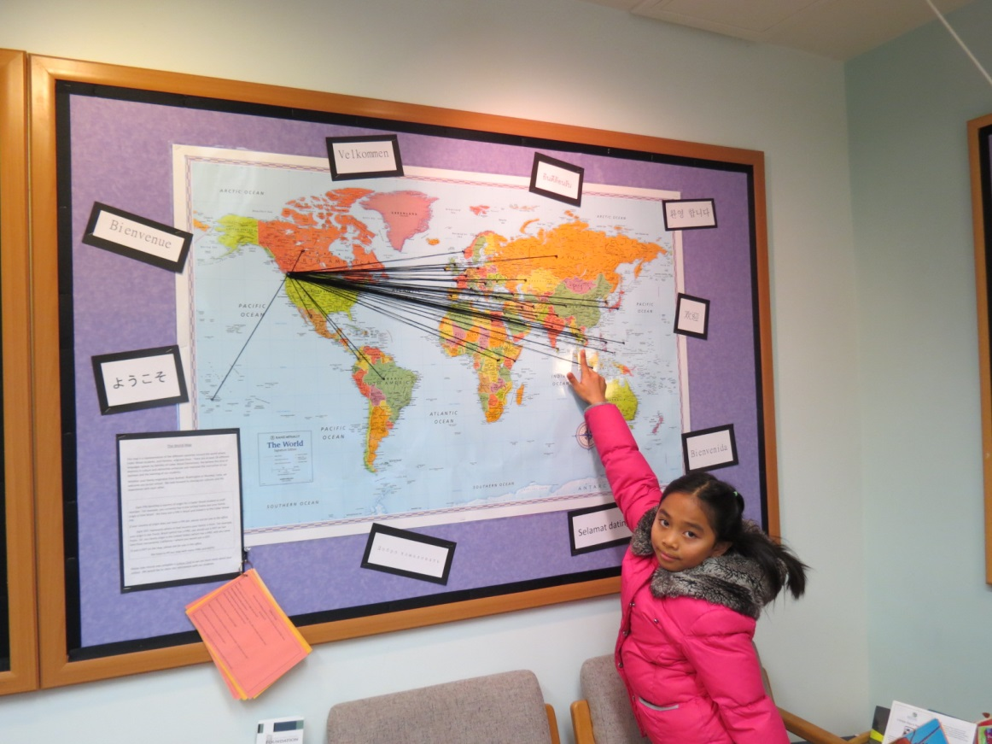

**We’ve put out the Welcome Map!**

**Student-crafted benches provide casual locations for impromptu parent interactions while waiting for the dismissal bell each day. We are promoting cross-cultural friendships.**

**New students visually document their home countries and share their language on the office welcome map.**